Overview

This lab will familiarize students with the basic principles of HTML authoring. One good source to learn more about html is www.htmlhelp.org. Another is w3schools.com

The lab consists of five exercises:

- Set up environment to access website
- Create a simple HTML page
- Extend that page with:
  - Hyperlinks
  - Images
  - Sound
  - Third-party applications
- Create a table
- Set up cascading style sheets

Exercise 1: Create a simple HTML page

A website is nothing more than a set of files written in a language that a webserver can understand. When you connect to a website, you really connect to a webserver, and give the webserver a file to load. The webserver loads and interprets the file. Thus, to mount an application on a website, all you need to do is put the appropriate file in the appropriate directory. The person in charge of hosting the website will do all the rest.

In your case, this is the directory space on https://files.000webhost.com. Anything you put there will automatically be mounted on the website.

Exercise Procedure

Subgoal A: the HTML, head, and body tags

Unlike MS Word, which marks up text visually, text in HTML is marked up using special, typed commands. Commands in HTML are enclosed by angle brackets “<>”. If a command has both a “beginning” and an “end,” the “end” is marked with angle brackets and a slash “</>”. Commands in HTML are called tags.

Almost all HTML files start with a particular structure. Go to 000webhost, and create a new file called homework2-html.html. Type this into the new file:

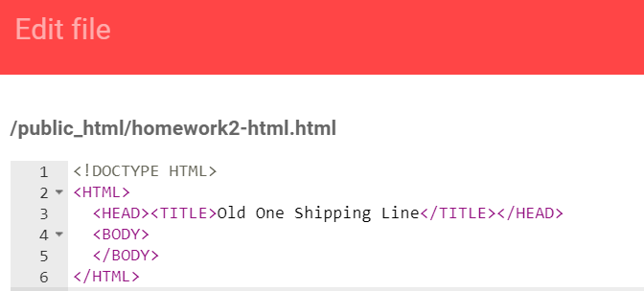

Save your file, and view it in the browser.

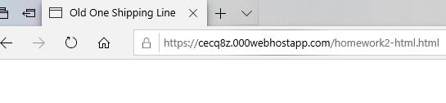
The main part of the page doesn’t show anything yet, but you should see the title of the tab change.

The <!DOCTYPE HTML> tag is a tag that actually does nothing for your webpage. It tells the browser to render your code in a particular way.

The “<HTML>…</HTML>” tag signals to the computer that you have created an HTML page (as opposed to a plain text file).

Anything in the “<HEAD>…</HEAD>” tag is information for the web page header.

Anything in the “<BODY>…</BODY>” tag is information that will appear in the main body. We will begin entering “body” information in the next subgoal.

Subgoal B: Paragraphing

Most body text in HTML is divided into paragraphs. One denotes a paragraph by inserting text within “<p>…</p>”.

Let’s try writing some paragraphs. Within the “<BODY></BODY>” text, type the following:

Save your file, and click “refresh” on your browser.

This is what you should see:

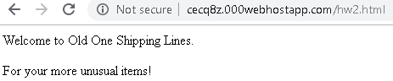

Subgoal C: Hierarchical Levels

Most documents have hierarchical levels. For example, books have titles, chapters, and sections. HTML provides for hierarchical levels with the tags <H1>, <H2>.. <Hn>.

Immediately after the opening body tag “<BODY>”, type:

Immediately after the first paragraph, type:

Overall, your typed document should look like this:

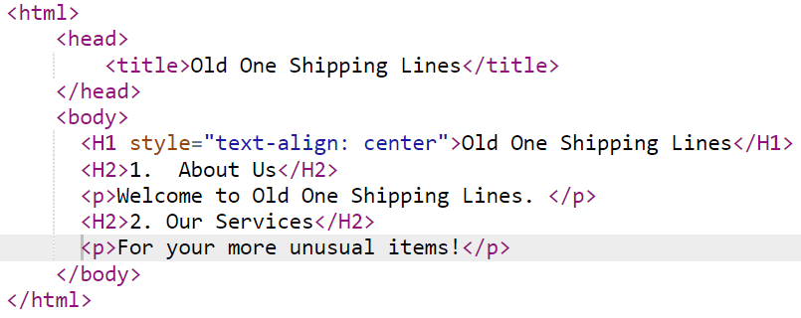

Once you save it, your screen will look like this:

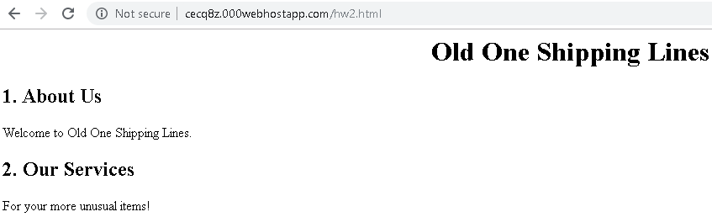

Note the special style="text-align: center" argument for <H1>. This argument tells HTML that the text enclosed in that heading should be centered.

Subgoal D: typefaces

The style argument is used on the web to change the way the web page looks. It uses a language called cascading style sheets (CSS) to format your document. Yes, CSS is different from HTML.

Commands in the CSS language basically have two parts: the property, and the value of the property you want to set. The property comes first, denoted by a colon, and the value comes second. For example, to set something to bold, you would set the font-weight property to the value bold like: “font-weight: bold;”

You can change anything in HTML using by putting a style argument in the tag. But what if you want to change something that isn’t wrapped with an existing HTML tag? We can wrap whatever it is with a <span> tag, and then style the <span> tag.

Let’s demonstrate the <span> tag and the distinct typefaces available with CSS with an example.

Just before the closing body tag “</BODY>”, type:

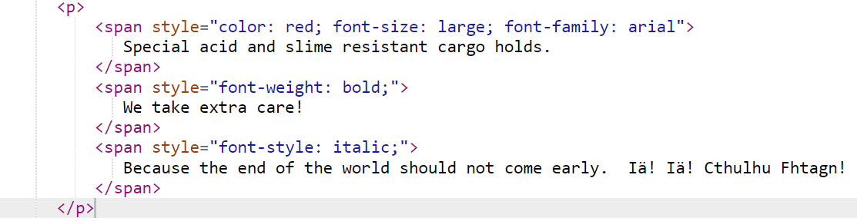
This is what your page should look like:

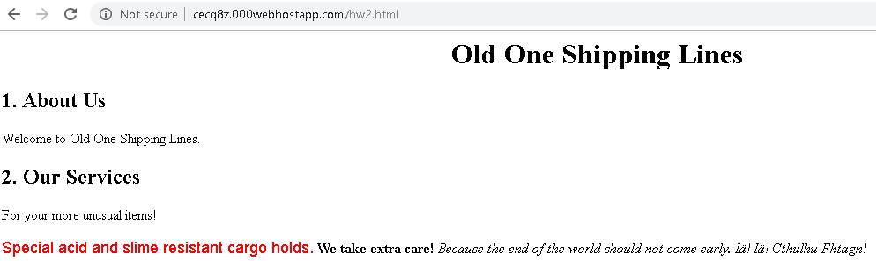

Subgoal E: Lists

The last paragraph of our web page would be better off if we segmented it into lists. Two list mechanisms will be introduced here, the unordered, and ordered list.

For both kinds of lists, list elements are prefaced with the tag “<li>”. Unordered lists are identified with the tag “<ul>…</ul>”, and ordered lists are identified with “<ol>…</ol>”.

To see how unordered lists work, change the last paragraph of text (i.e., replace the <p></p> tags as follows. Highlighted items are the ones to include:

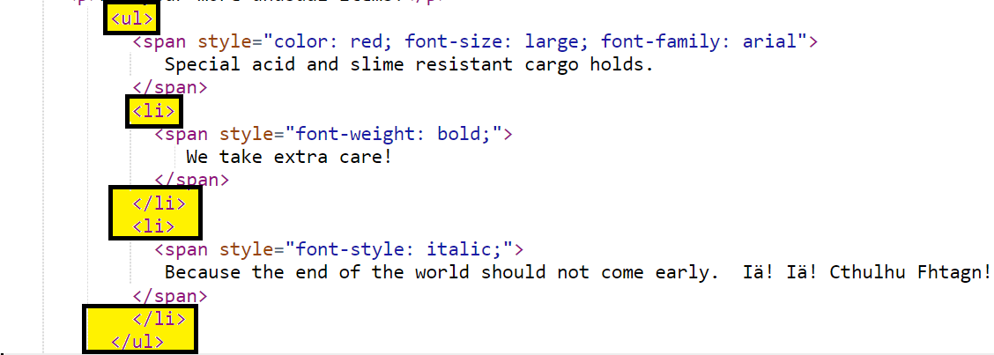
Note that the <ul></ul> tags replace the <p></p> tags.

Your web page should now look like this:

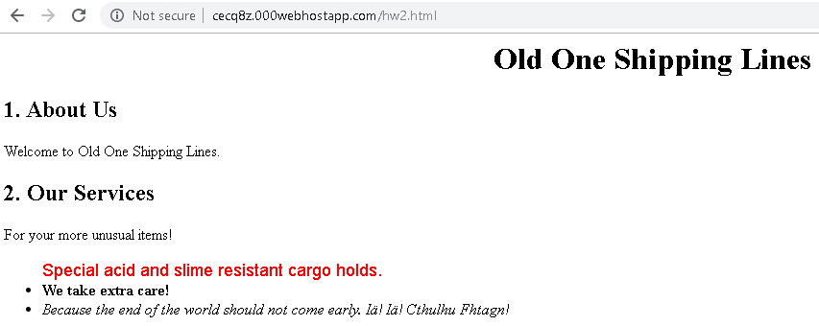

Now change the unordered lists to ordered lists by changing the <ul>…</ul> tag to <ol>… </ol>. Your document should now look like this:

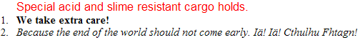

You can change the numbering style of the ordered list. To change to small case letters, change the <ul> tag to
Don’t forget to change the equivalent closing tag.

Your web page should now look like this:
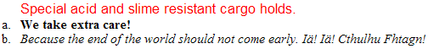

Exercise 2: Extended Features

Subgoal A: Images [To Add Local Image]

To include an image in your text, you must have the image available somewhere. You then link to the image with the command “<IMG Src= “…” Alt= “…”>

Let us try with an example. Download the cthulhu.png picture and upload it to webhost. In the H1 tag, type the bolded text:

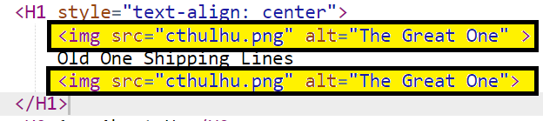Wow, that looks awful! The picture needs to be shrunk. Change the style so the width is only 30 pixels. This will simultaneously scale the length.

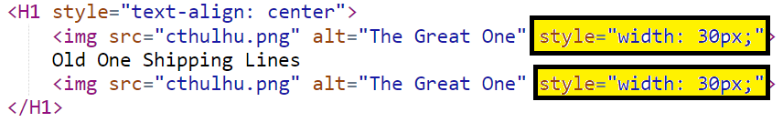
Pixels are dots on the screen. Your screen should appear like this:



Subgoal B: Sound

We’re going to add the unsolved bloop sound (http://en.wikipedia.org/wiki/Bloop) to our website. Download and upload bloop.mp3 and add the following to your webpage.

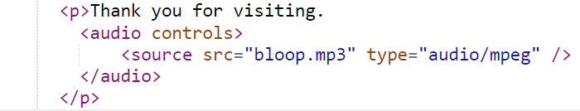
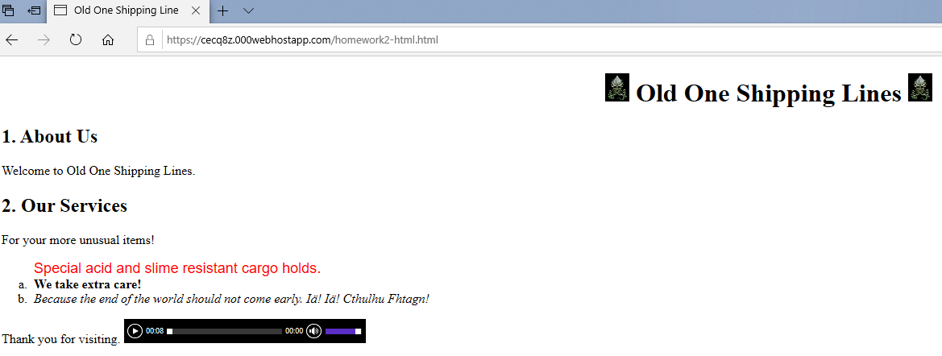

Subgoal C: Hyperlinked References

One of the advantages of HTML over regular text is hyperlinks, or the ability to link to other kinds of documents. Hyperlinked references are created using “anchor text”, denoted as “<a>…</a>” in HTML. Let’s create some anchor text now. After the last paragraph, type the following text:

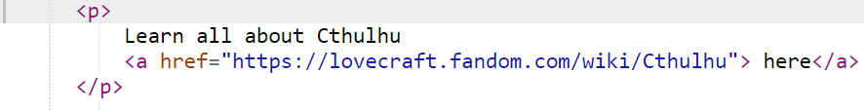
Your screen should now appear like this:

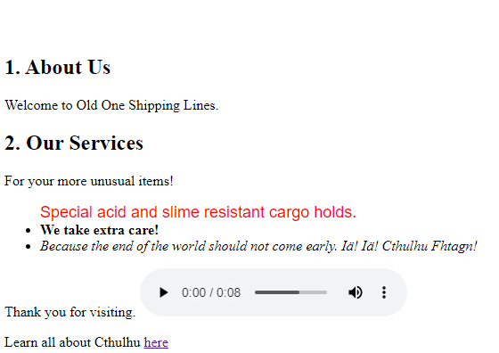

Exercise 3: Tables

Create a new section. In that section, we’re going to create a table.

Type the following:

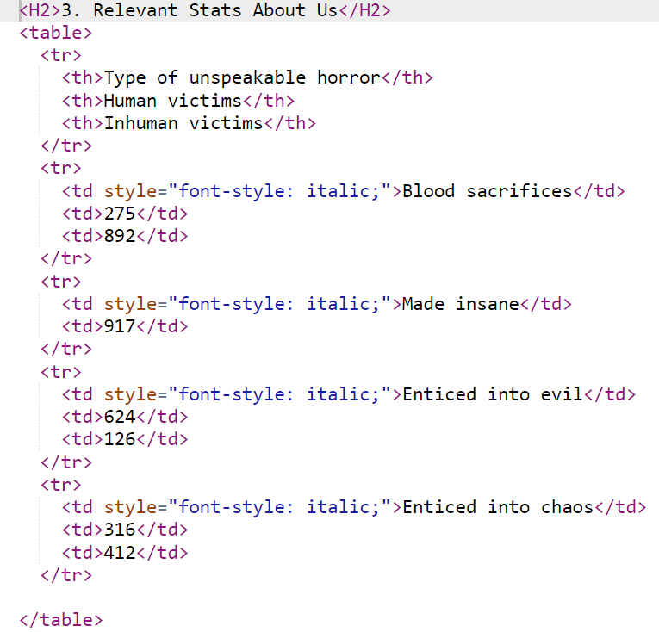
Tables are complex HTML structures. Every table is defined with a table tag. Tables are then defined as a set of rows with the tr (table row) tag. Within each row, we define cells with the td (table data) tag. We can optionally define header cells with the th tag (table header). These are td tags, but are formatted differently. If you typed everything right, this is what you should see:

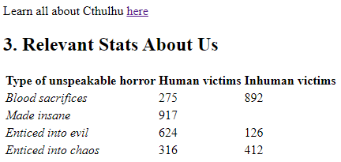
Let’s put a border around our table.

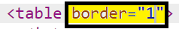
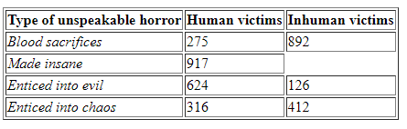

Sometimes, we want information to span multiple columns or rows. We cross columns and rows with the colspan and rowspan arguments. Revise your table as follows:

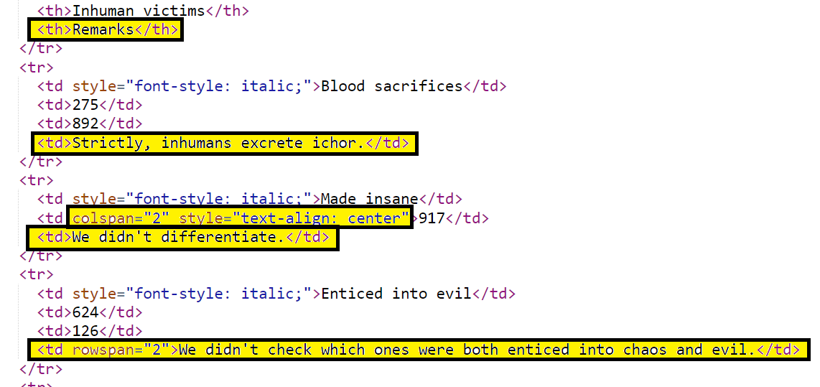
</table>
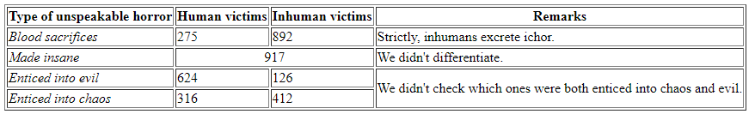
Observe how the 2nd column in the 3rd row spans two columns and the final cell spans two rows.

Exercise 4: Using CSS

Modify your html as follows:

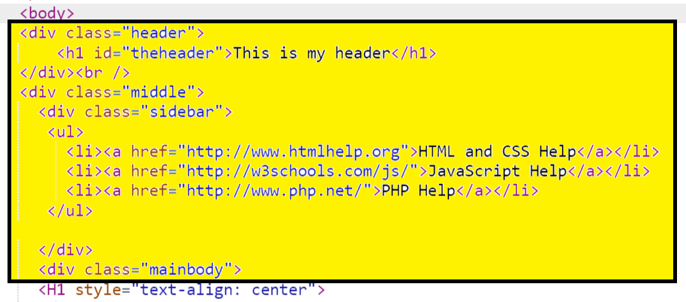.
.
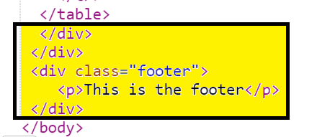
What we’ve done is defined three sections in our HTML, which we call header, middle, and footer. Inside middle, we’ve defined sidebar and mainbody.

Right now, these sections don’t do anything yet.

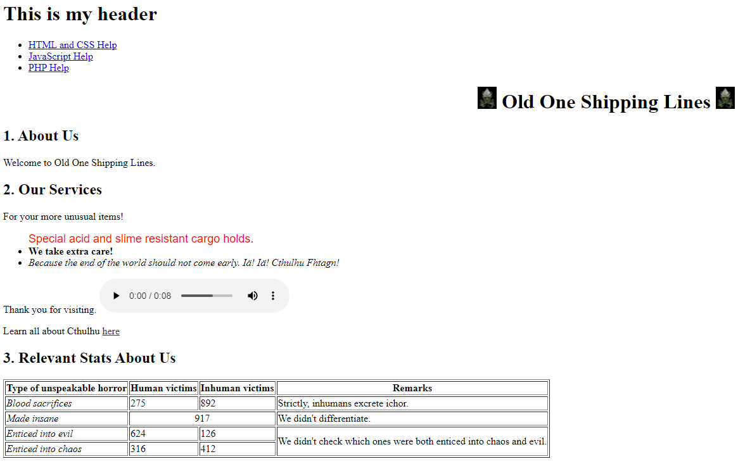

To format these sections, we need to style them with CSS. We do this by putting a style tag inside the head tag.
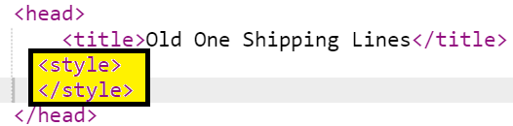

Now, let’s just format the overall page. Because we are evil Cthulhu worshippers, we want the color of the background black and the color of the text white. We will set anchor text to gray.
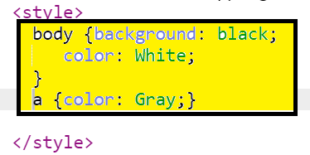

Observe how this has changed your web page:
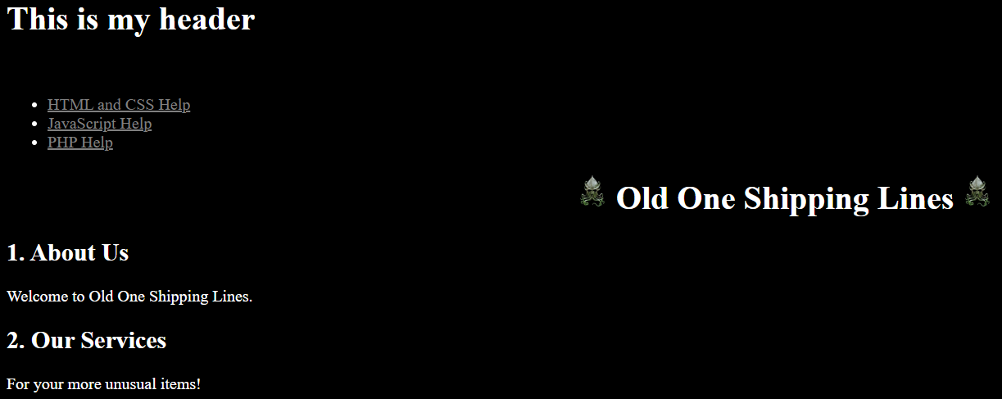

Now, let’s format our header and footer. They will be on the very top left and bottom left of the screen. They will stretch to be the width of the whole screen. They will be 75 pixels high. We want things in the header to be centered.

Vw is View Width- the visible width of the screen.
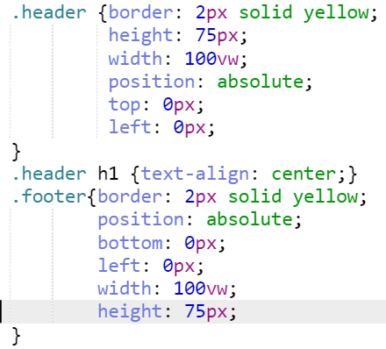

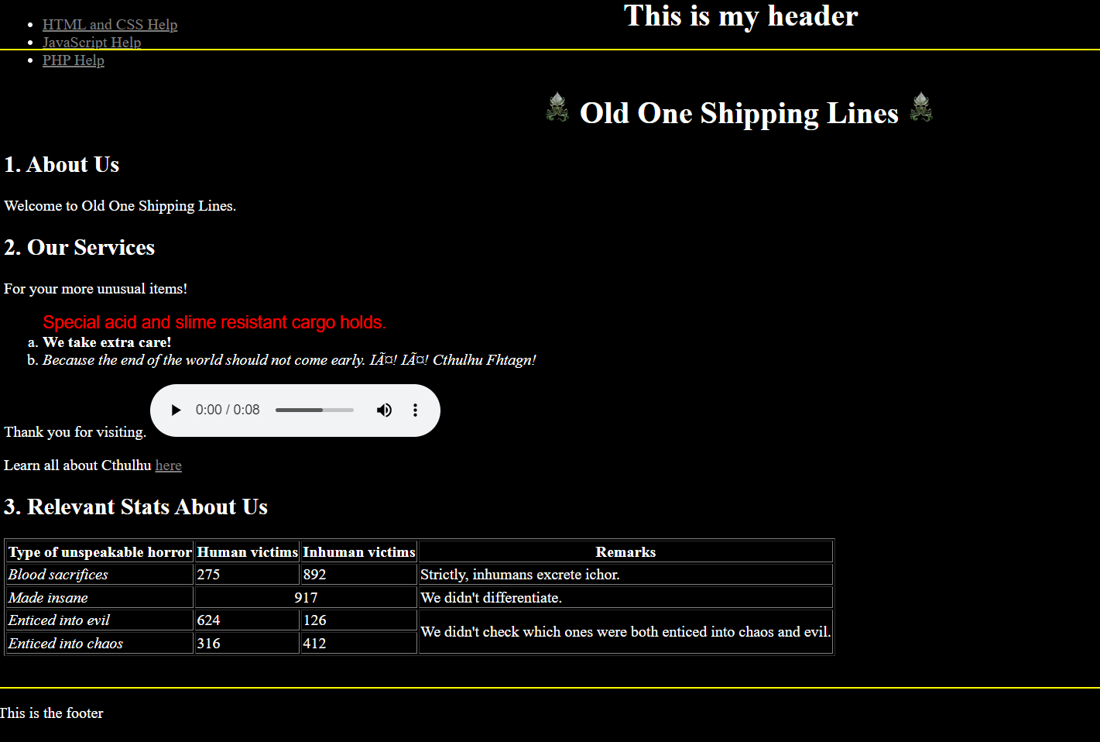

Now we will define our middle. It will begin where the header left off- 0 pixels to the left and 75 pixels from the top. It will stretch to where the footer is- 75 pixels from the bottom. We want it to fill all the horizontal space. It is going to have two subparts that we want to manage flexibly.

The sidebar is going to be a fixed width. Further, we want special effects to occur when we hover over the sidebar, and when we click the sidebar. We also want the sidebar to change color after we have visited a hyperlink.

The main body will fill all the available remaining width (and height).

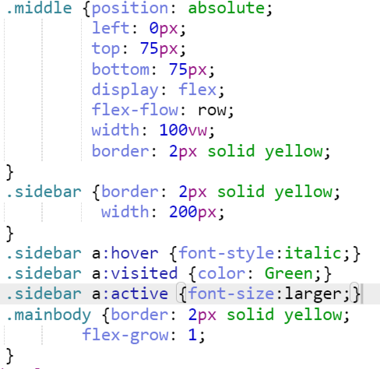

If you set things up right, your web page should now look like this:

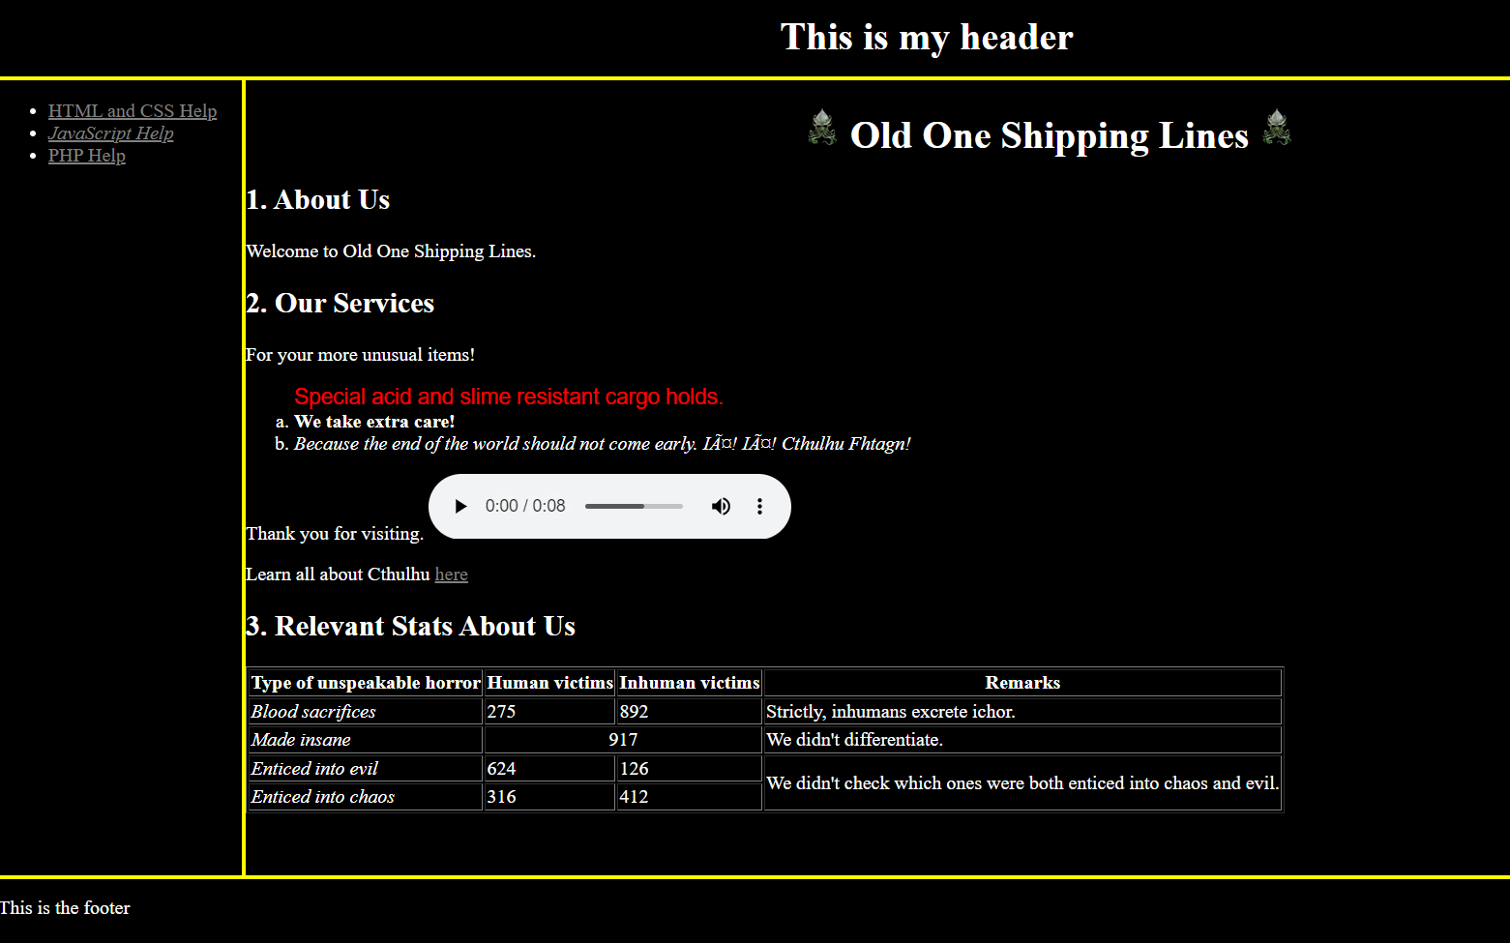

Finally, in many cases, you want the formatting of all your webpages to have a consistent look and feel. If that’s what you want, take all the stuff in the style tags and put it into a separate file. We’ll call that file cssex.css. Then, change the <style> tags into a link tag as follows (make sure you delete the style tag and everything in it):

<head>
<link href="cssex.css" rel="stylesheet" type="text/css" />

CSS is called cascading style sheets, because instructions to CSS are rendered in a hierarchy. CSS commands in the style= tag take priority over CSS commands in the style tag. These take priority over CSS commands in the link.

Once done, submit the URL to this page on Canvas.

